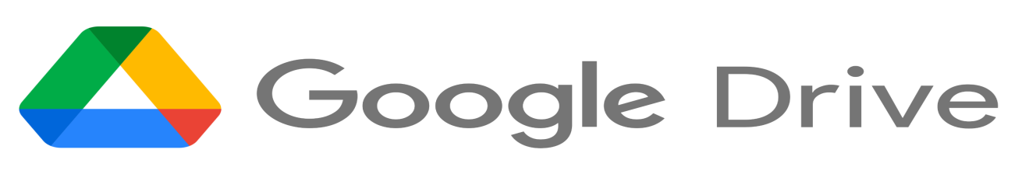

Google Drive is a cloud-based storage solution that allows you to save files online and access them anywhere from any smartphone, tablet, or computer.

Using a cloud storage service like Google Drive has plenty of advantages, such as easier file sharing and having a remote location to backup your files. But when compared to competitors like Drop Box and Apple's iCloud service, Google Drive's popularity is built on useful collaborative tools and built-in integrations with Google's suite of products and services.

Google Drive gives you the power to upload and save a range of file types — documents, photos, audio, and videos — to Google servers, or the "cloud." Drive can serve as a backup solution, or as a way to free up space on your device.

To understand why Google Drive is so popular, it's important to note that it's built to work seamlessly with Google. And one of Drive's best features is its integration with Google's office suite of cloud-native apps, which, if you have experience with Microsoft Office, will look familiar.

Most users will gravitate to these programs, which include Google Docs, Sheets, Slides, and more. Not only do they let you create and edit documents, they're

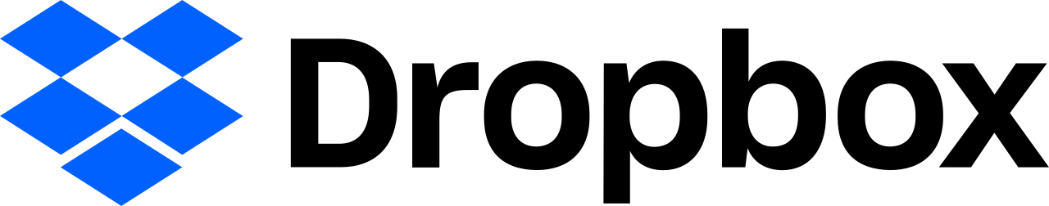

* Dropbox is a cloud storage service that lets you save files online and sync them to your devices.
* You can use Dropbox links to share files and folders with other people without sending large attachments.
* Dropbox offers a free plan that includes 2 GB of storage. You can pay to increase that to as much as 3 TB with a subscription.

Dropbox is a file hosting service, often referred to as a "cloud storage" service. Dropbox is one of the oldest and most popular cloud storage services in use today, though there are many alternatives, including Microsoft OneDrive, Box, Sync, and Google Drive.

When you subscribe to Dropbox, you are allotted a certain amount of storage space in an online server known as "the cloud." After installing the Dropbox app on your PC, mobile device, or both, any files that you store in your Dropbox locally will be copied to the Dropbox server as well.

Dropbox is a cloud storage service that keeps files in sync between an online server and your own devices.Dave Johnson/Business Insider

If you make changes to these files in one place, the updates are automatically mirrored everywhere.



*One Drive*  is an internet-based storage platform with a significant chunk of space offered for free by Microsoft to anyone with a Microsoft account. Think of it as a hard drive in the cloud, which you can share, with a few extra benefits thrown in. One of the primary benefits: OneDrive hooks into Windows 10, at least in fits and starts.

Microsoft, of course, wants you to buy more storage, but you’re under no obligation to do so.

As of this writing, OneDrive gives everyone with a Microsoft account 5GB of free storage, with 50GB for $2/month. Many Office 365 subscription levels provide 1TB (1,024GB) of OneDrive storage, free, for as long as you’re an Office 365 subscriber.

Microsoft’s offers change from time to time, but the general trend is down — prices are going down, fast, and it won’t be too long before most online storage approaches free.

The free storage is there, regardless of whether you use your Microsoft account to log in to Windows, and even if you never use OneDrive.

One Drive does what all the other cloud storage services do — it gives you a place to put your files on the internet. You need to log in to OneDrive with your Microsoft account (or, equivalently, log in to Windows with your Microsoft account) to access your data.

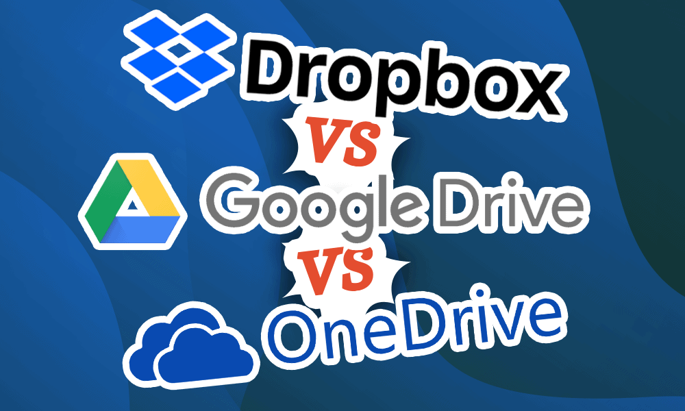

If you were to ask someone to rank and contrast cloud storage services, it would be a good bet that comparing Dropbox vs Google Drive vs OneDrive would get a mention.

It’s no surprise why. Dropbox is the cloud storage service that really popularized the concept, and Microsoft and Google are two of the biggest players in the software sphere. If you’re thinking about signing up for cloud storage, you might wonder who wins in a battle between Dropbox vs Google Drive vs OneDrive on pricing, features and more.

**Key Takeaways:**

* In the battle of Dropbox vs Google Drive vs OneDrive, it’s hard to call a winner, as the best service will depend on your cloud storage needs.
* Google Drive offers the largest free plan and the cheapest paid cloud file storage of the three.
* None of the services are particularly secure, but OneDrive offers a secure folder locked by an extra level of two-factor authentication.
* In the end, the results are a true toss-up between Google Drive, OneDrive and Dropbox, with each service scoring three points in different categories.

## Which Is Better: Dropbox vs Google Drive vs OneDrive?

These are three huge names in cloud storage, so which one comes out on top as the better cloud storage provider? The quick answer is a disappointing “it depends.” Well, at least of these three: Google Drive vs Dropbox vs OneDrive. However, Sync.com is our absolute favourite.

#### OneDrive for Ease of Use and Mobile App Support

Microsoft OneDrive is easy to use and offers fast syncing — you can also manage multiple OneDrive accounts. Although it’s not the best cloud storage provider on the market, it still offers better security features than the other two providers.

#### Dropbox for File Syncing and File Sharing

Meanwhile, Dropbox scores very highly for features, especially if you’re looking for a product that’s ideal for collaborating on both Microsoft Office and Google Workspace documents. However, it does have some flaws, especially for Mac and iOS users, which we’ll cover in further detail.

#### Google Drive for Features, Customer Support and Pricing

Lastly, Google Drive offers the most free storage space and has better customer service, but there are well-known privacy issues.

**Features :**

First, let’s take a gander at the features these cloud storage providers offer. We’ll compare them not only on the features each offers out of the box but also on third-party app integrations. We’re especially interested in how these cloud services can facilitate productivity and collaboration.

**Microsoft OneDrive Features**

OneDrive is a Microsoft cloud storage product, so it plays very nicely with other Microsoft apps. For example, if you receive an attachment in Outlook, you can right-click and save it directly to any OneDrive folder of your choice. As part of Microsoft 365, OneDrive comes with all the perks of integrating natively with both Microsoft’s apps, like the Office 365 suite, as well as Windows itself.

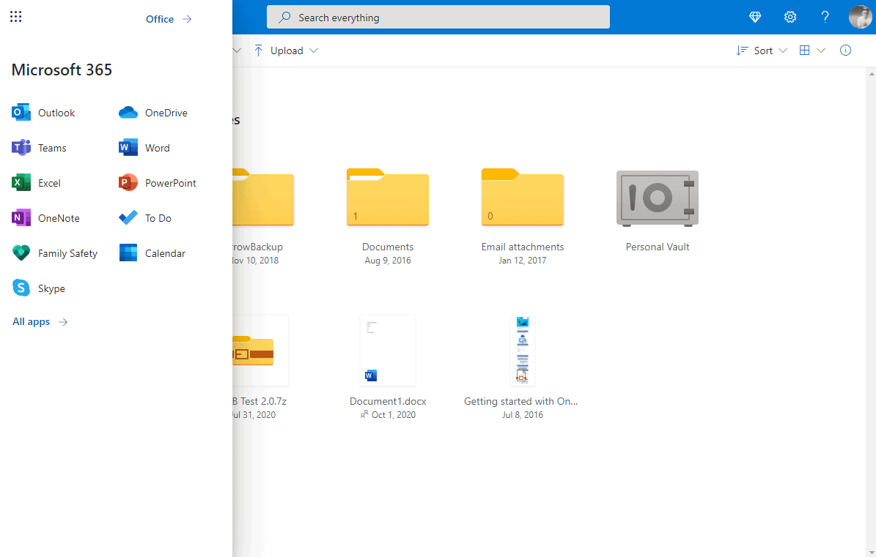

*Microsoft’s OneDrive cloud storage integrates natively with other Microsoft apps.*

Unfortunately, there aren’t any third-party integrations to speak of unless you’re on the business version of OneDrive. While there are apps that work with OneDrive, it’s more of a case of the apps having integration with OneDrive, rather than the other way around. This is also the case with Google Drive and Dropbox, as you’ll see further down in this comparison.

**Google Drive Features**

Likewise, Google Drive works seamlessly with other Google Workspace apps, such as Google Docs and Google Sheets (find out how to change your default Google account). Integration with Gmail is also excellent. You can attach a file from your Google Drive directly from within the “compose” window.

*Besides integrating with Google apps, Google Drive cloud storage has an entire app store for third-party integrations.*

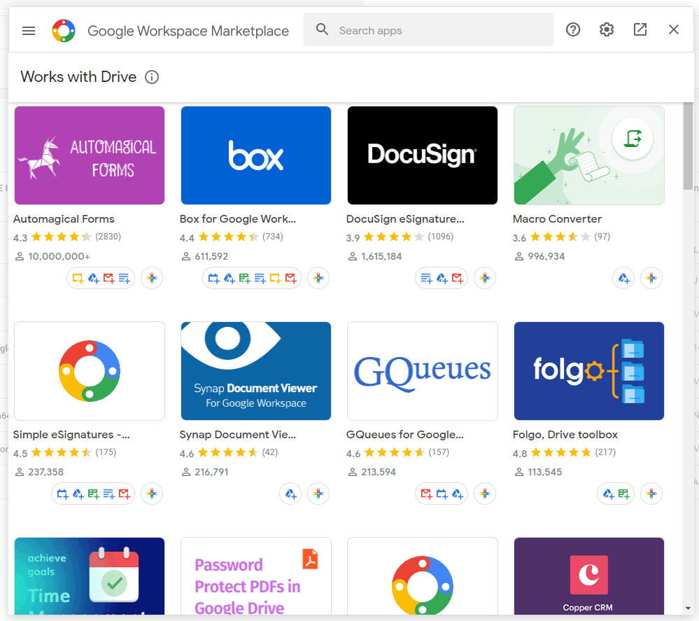

Where Google Drive beats Microsoft OneDrive is integration with third-party services, meaning you don’t have to rely on Google’s default feature set. You can use third-party media players, photo and video editors, accounting software and more in your Google Drive interface.

**Dropbox Features:**

Unlike Google Drive and OneDrive, Dropbox cloud storage doesn’t have its own office suite or email client, but it does offer a note-taking app (see our [Dropbox Paper review](https://www.cloudwards.net/dropbox-paper/)), as well as a document signer, a file transfer service and a password manager. It even lets you take and share screenshots and screen recordings.

However, because of its lack of office apps, you might expect Dropbox to be less useful as a collaborative tool. In fact, the opposite is true, as Dropbox works with files from both Microsoft and Google. If you want to switch between services, Dropbox makes this easy. Rather than having to decide which service you’d prefer to use, Dropbox allows you to use both.

*Dropbox offers a few features of its own, plus an app store to download third-party app extensions.*

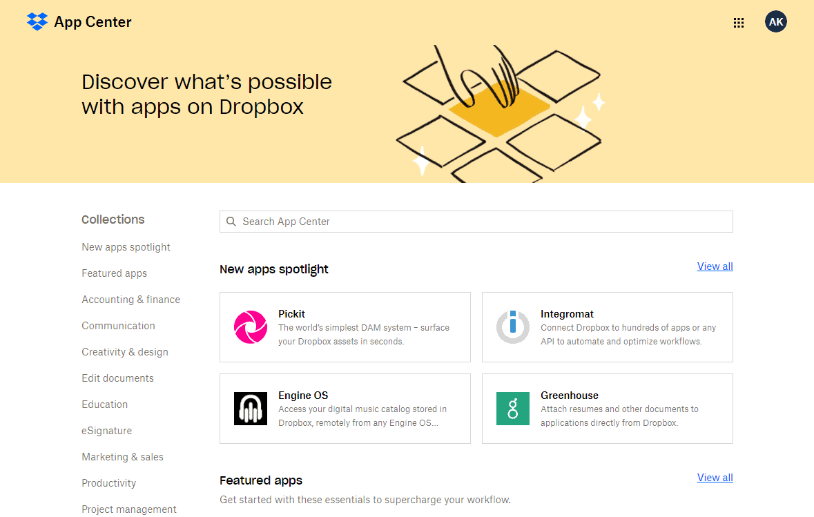

As for integration with other third-party apps, Dropbox has its own app store where you can find add-ons for everything from project management apps like Trello and IFTTT to full-on design apps like Canva, Procreate and even AutoCAD.

**Pricing**

All three providers offer some level of free storage, as well as various perks that come with a paid account. If you’re not looking to store a huge amount of data, then there are well-priced cloud storage options from all three providers. In fact, all three cloud storage services make it onto our list of the best 1TB cloud storage providers. First, let’s take a look at what each service offers for free.

**Dropbox vs Google Drive vs OneDrive: Free Storage Space**

Dropbox and OneDrive don’t really offer too much free cloud storage space. Dropbox offers a measly 2GB for free, while OneDrive offers only 5GB. Both services are similar in that they limit certain features from free accounts.

The free version of OneDrive has limited sharing features and a limit of three files for your “personal vault” (we’ll look into these features in a bit). Similarly, a free Dropbox account has no advanced sharing features or access to the Dropbox Vault, and although Dropbox still keeps a 30-day version history of your files, you can’t use the full “account rewind” feature for free.

Google Drive comes out the highest of our three contenders in our rundown of the best free cloud storage providers, offering a generous 15GB of free storage. Besides beating both OneDrive and Dropbox in terms of sheer free storage space, the free version of Google Drive has no limitations like the other two cloud storage services do.

**Dropbox Pricing Plans**

Dropbox has only one personal plan, the Dropbox Plus plan. It costs $9.99 per month for 2TB of cloud storage space and adds all the perks missing from the free plan. There’s also the shared Family plan, which costs $16.99 a month for 2TB of shared file storage space. You can add up to six users to this plan and get a common “family room” for mutually accessed files.

**Microsoft OneDrive Pricing Plans**

Looking at the OneDrive storage plans, you get cheap cloud storage, plus access to other Microsoft apps, but the cap for storage is low — only 1TB. There’s only one OneDrive subscription option, with 100GB for just $1.99 per month, although this doesn’t come with access to Office apps. To get more storage than that, you have to get a Microsoft 365 plan.

**Google Drive Storage Pricing Plans**

Google Drive offers the cheapest file storage of the bunch, so it’s a no-brainer between Dropbox prices vs Google Drive prices. Plus, unlike Microsoft’s Office, Google’s document editors are completely free to use (though the less-capable online versions of Office apps are free).

**File Sharing**

All three providers make file sharing simple by creating shareable links. Dropbox and Google Drive even squeaked onto our list of the best cloud storage for sharing , although other paid providers like pCloud beat it.

Each service gives you the option to determine whether the recipient can edit or view a file. Google Drive also allows you to set who can comment on the document. Check out our guide on how to share files in Google Drive if you want to know more.

Dropbox and OneDrive also allow you to password-protect your links and set expiration dates to provide temporary access. This isn’t something that Google Drive allows you to do unless you have a paid Google Drive for Business account.

**Ease of Use**

OneDrive and Google Drive offer desktop apps for both Windows and macOS, but neither has a Linux desktop app. OneDrive comes preinstalled on Windows 10, but you’ll need to sign in to use it.

No matter what operating system you’re using, you’ll find a Dropbox app for it. Unlike Google Drive and OneDrive, Dropbox also offers a Linux client, and it’s of the best cloud storage services for Linux users, alongside MEGA (read our Dropbox vs MEGA guide and our MEGA review).

**Mobile Apps**

All three providers offer mobile apps for Android and iOS. On the whole, these all appear fairly similar, although the Dropbox app has a serious flaw in the iOS version, as we’ll see shortly.

We’ve seen solid performance from all three apps on Android, with all three making our best cloud storage for Android short list. All three cloud storage services also have stellar iOS mobile apps .

In the Google Drive mobile app, the “home” tab shows suggested files, according to your usage. You can also view your My Drive folder, any synced computers, shared and starred files, as well as any shared drives if you’re on Google Workspace.

The Dropbox and OneDrive apps are similar and include a photos page that allows you to search your photos. You can install Google Photos if you want more similar functionality for your Google Drive images. The OneDrive and Dropbox apps also include an account section, where you can see relevant information, such as how much storage you’re currently using.

For general use, all three apps are fairly similar. However, Dropbox and OneDrive offer useful scanning features that Google doesn’t. With more functionality and slightly better features, OneDrive nudges past Google Drive to be the winner here, although all three apps offer a pretty good experience on mobile devices.

**Privacy**

As with security, none of the providers here have a great reputation when it comes to privacy, either. If you’re looking for a cloud storage provider that respects your privacy, then there are better options out there.

**Google Drive Privacy Policy**

The Google privacy policy states that it will “collect the content you create, upload or receive from others when using our services” and includes emails, documents you create and comments you make on Google platforms like YouTube. Google states that it collects this data to provide better services as well as personalized ads.

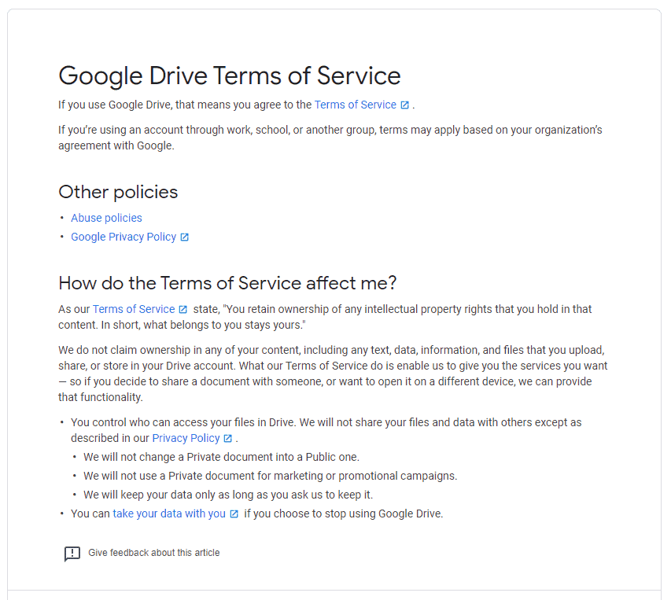

*Google collects the most data of the three services in this comparison.*

**OneDrive Privacy Policy**

OneDrive is a little less intrusive. The Microsoft privacy policy states that it doesn’t “use what you say in email, chat, video calls or voicemail, or your documents, photos or other personal files to target ads to you.” Despite this, with no zero-knowledge encryption and files based in the U.S., Microsoft engineers can access your files if required to do so.

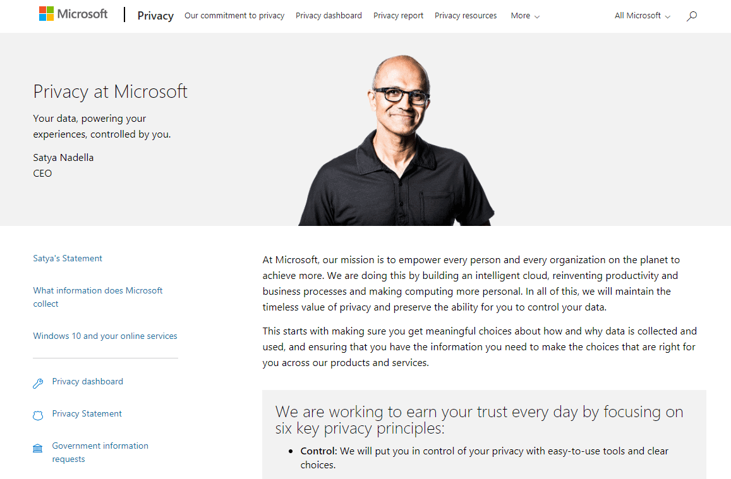

*Satya Nadella’s smiling face atop Microsoft’s privacy statement doesn’t do much to assuage our concerns about its data collecting.*

**Dropbox Privacy Policy**

Dropbox’s privacy policy states that it collects your data for a number of reasons, including “investigating and preventing security issues and abuse of the Dropbox services or Dropbox users.” It also admits that the data analyzed includes “your stuff,” which is “what you decide to store in your Dropbox account” — meaning your files.

Not only that but it also discloses your data to “trusted” third parties that include Amazon Web Services, Google and Zendesk. Dropbox was also famously hacked in 2012, with a leak of nearly 70 million user passwords, although it has upped its game since then.

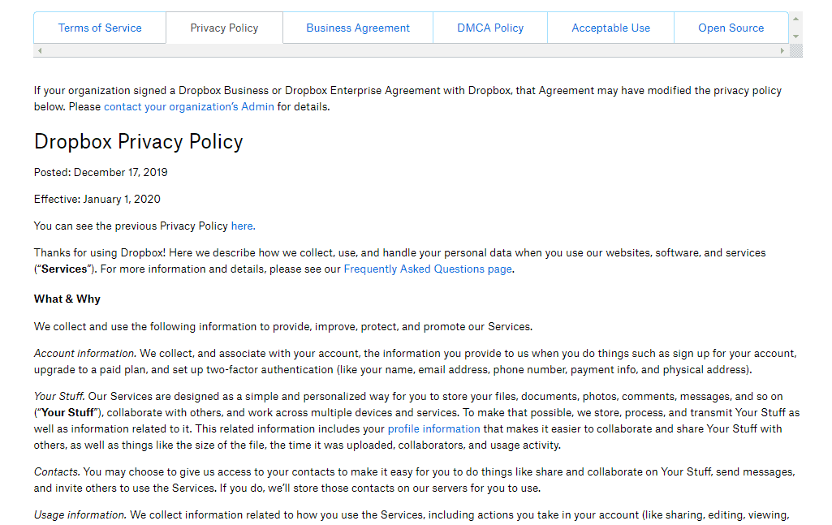

*Dropbox doesn’t collect as much data as Microsoft or Google, but it’s had numerous leaks in the past.*

This means that whichever service you use, you might have a complete stranger sifting through your files, which is not an appealing thought.